KURO

Information for invitation to tender

228249

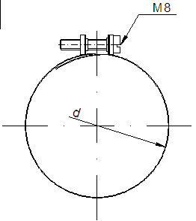
Product:

Wide Band Hose Clamp
- made of INOX band
- inclusive 2 screws

Text for Invitation to tender:

 | Pos: ....................... | Wide Band Hose Clamp
 |  | made of INOX band, inclusive 2 screws
Dimension: 104 mm
NW: 100
 |  | Width: 90 mm
 |  | System KURO or equal (www.kuro-kunststoffe.com),
 |  | deliver and assemble.
 |  | Quantity: ............ pc Price/Unit: .......... Price total: ..........
 | Pos: ....................... | Wide Band Hose Clamp
 |  | made of INOX band, inclusive 2 screws
Dimension: 110 mm
NW: 110
 |  | Width: 90 mm
 |  | System KURO or equal (www.kuro-kunststoffe.com),
 |  | deliver and assemble.
 |  | Quantity: ............ pc Price/Unit: .......... Price total: ..........

 | Pos: ....................... | Wide Band Hose Clamp
 |  | made of INOX band, inclusive 2 screws
Dimension: 160 mm
NW: 160
 |  | Width: 90 mm
 |  | System KURO or equal (www.kuro-kunststoffe.com),
 |  | deliver and assemble.
 |  | Quantity: ............ pc Price/Unit: .......... Price total: ..........

